IDC does not operate outside of the law, says board chairman
25-January-2019
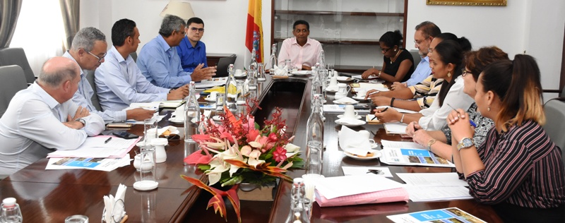
The chairman of the Island Development Company (IDC), Patrick Berlouis, has stressed that, opposed to what has been said over the last few months by some, IDC does not operate outside of the law.
“IDC has its management and board of directors to oversee the operations and management of the company. It does not operate outside of the law, […] that’s a bit unkind to say,” Mr Berlouis told members of the press.
Mr Berlouis was speaking in an interview following a meeting between President Danny Faure and the IDC board of directors at State House yesterday.
Mr Berlouis explained that IDC abides by the required laws but that perhaps its main challenge is in communicating properly with members of the public.
In order to educate the public about these islands and shed light on how they are managed, Mr Berlouis added that the Seychelles Broadcasting Corporation (SBC) will soon broadcast a monthly docu-series on the islands.
In conjunction with that, IDC plans to kickoff a programme that will hopefully increase the number of Seychellois visitors to the islands.
“This year we’ll have Desroches, Alphonse, Astove and Farquhar part of that circuit. It won’t be massive tourism, because the islands won’t be able to sustain that, but we’ll start getting people to know the islands better.”
In fact, IDC is embarking on a long list of other projects and initiatives for 2019 and the subsequent years which the board discussed in length with President Faure during the meeting.
These include future agricultural developments on Desroches, where IDC wants to undertake a livestock programme with the private sector.
According to Mr Berlouis another 334 hectares of land on Coëtivy, which only recently housed prisoners, have also been demarked for future agricultural developments. The island is expected to be leased to IDC.
The company’s projected plans for 2019 and coming years also include a long list of construction projects, tourism-related developments and renewable energy initiatives.
President Faure additionally received a full-appraisal of the past performances of IDC, a discussion which was facilitated thanks to IDC’s recent annual audited report for 2014-2018 and which the President received a copy of.
Aside from providing information on the structure of IDC, the report outlines IDC’s consolidated statement of income from March 31, 2015 to March 31, 2018 as well as their dividend payouts among other crucial information.
Mr Berlouis confirmed that they also approached the topic of the Green Island Construction Company Limited (GICC), one of IDC’s subsidiary company.
To recall, GICC received some backlash from certain politicians who argued that IDC’S mandate is to manage the outer lying islands and not to compete with other construction firms for commercial projects.
Mr Berlouis confirmed that GICC is closing down on its commercial activities with the exception of the condominium project after it completes some of its projects in December 2019.
Nevertheless GICC will continue carrying out developments for IDC.
In its report, IDC notes that “the winding down of GICC has impacted greatly on IDC’s overall financial performance as since May 2017 the company has not been taking on new clients and contracts”.
GICC’s revenue in 2018 represented only 24% of IDC’ s consolidated revenue compared to 63% in 2014, but nonetheless by the end of March 2018 the company completed 133 projects at a value of R686 million.
Mr Berlouis concluded that the meeting with the President went really well and that the President is satisfied with the work of IDC thus far.

